University of Cebu-Banilad
College of Computer Studies

IT-ELPHP
Lec- 12:30-1:30 PM
Lab- 1:30-4:30 PM
IT-ELDROID
Lec- 7:30-9:30 PM
Lab- 4:30-7:30 PM

Carpenter’s Choice

Submitted by:
Ivan Trapero
Rob Cabahug Yu
Christopher Reales
Victor Ymbong
Kim Baring
Godwin Enriquez

Submitted to:
Mr. Richyll Son

Overview
Carpenter’s Choice is a mobile application designed to streamline and enhance the woodworking industry by providing an all-in-one platform for tool rentals and purchases. Whether you are a professional carpenter, a DIY enthusiast, personal use, or a construction business owner, ensures that you have easy access to the tools you need, precisely when you need them.
At its core, Carpenter’s Choice functions as a dynamic marketplace where users can rent or buy a wide range of high-quality tools and equipment. The application eliminates the hassle of searching for tools by offering a centralized hub where availability, pricing, and rental durations are transparent and easy to manage. With its user-friendly interface, Carpenter’s Choice simplifies the process of acquiring tools, whether for short-term projects or long-term investments.
Beyond its marketplace capabilities, Carpenter’s Choice is equipped with advanced features designed to optimize the user experience and improve workflow efficiency. Real-time inventory tracking allows users to check tool availability instantly, while a secure reservation system ensures that users can lock in the tools they need without delays. Additionally, the platform offers flexible rental options, allowing users to select timeframes that align with their project timelines.
For suppliers and tool owners, Carpenter’s Choice presents an opportunity to monetize idle equipment by listing their tools for rent or sale. The seller program provides exposure to a broader audience, enabling businesses and individual owners to maximize their revenue potential. With an integrated rating and review system, users can make informed decisions based on community feedback, ensuring reliability and quality.
Carpenter’s Choice is more than just a transactional platform; it is a digital ecosystem that fosters efficiency and collaboration within the woodworking and construction sectors. The app integrates seamless logistics solutions, ensuring on-time tool deliveries and pickups, reducing downtime, and enhancing project productivity. Additionally, it promotes sustainable practices by encouraging tool sharing, reducing unnecessary purchases, and minimizing resource waste.
By harnessing the power of technology, Carpenter’s Choice envisions a future where woodworkers, builders, and craftsmen have immediate, hassle-free access to the tools they need to bring their projects to life. The application empowers professionals and hobbyists alike to work smarter, reduce costs, and embrace a more efficient approach to tool management. With Carpenter’s Choice, the right tools are always within reach, helping users achieve precision, creativity, and excellence in every project.

Entity Relationship Diagram
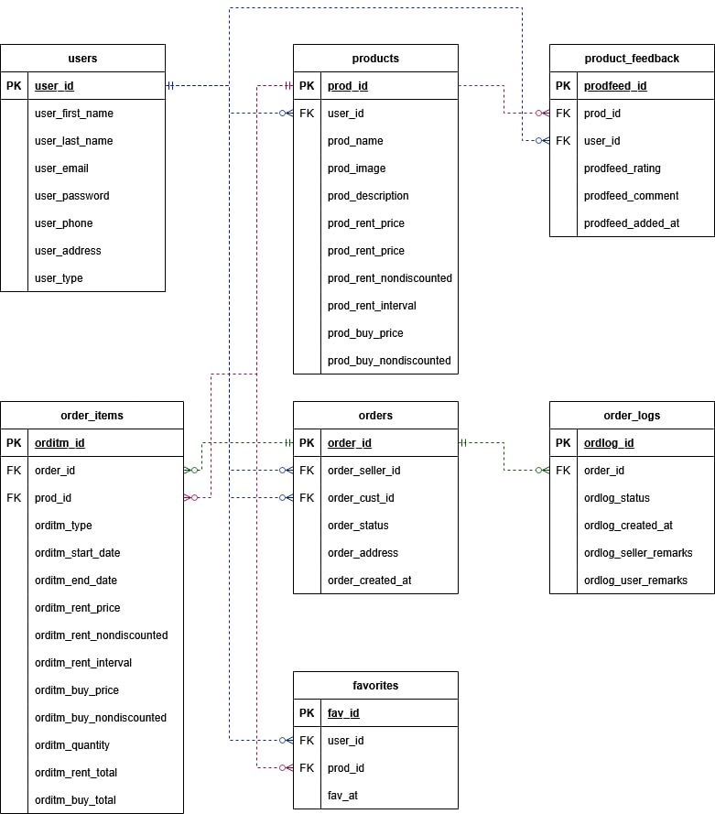

Use Case
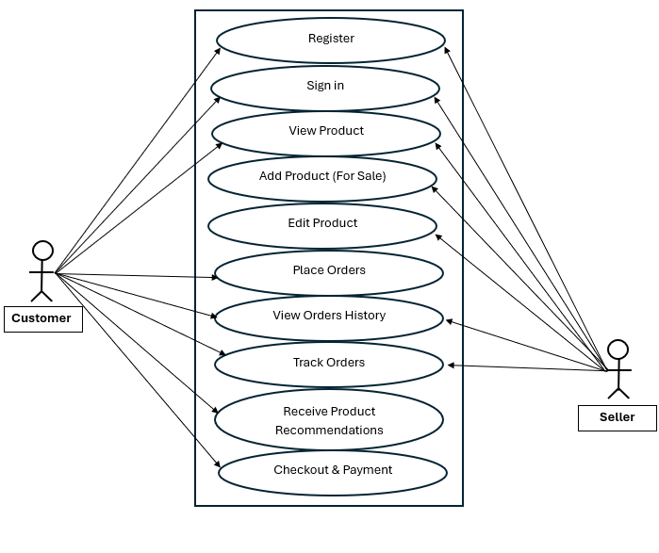

Database Design
An overview of every database table is provided in this section, along with the Table Name, Description, Null, Field Name, Data Type, and Field Size.
Users
Column Name | Data Type | Constraints | Description
User_ID | INT | PRIMARY KEY,  AUTO_INCREMENT | Unique identifier of the table
User_FirstName | VARCHAR(50) | NOT NULL | First name of the user
User_LastName | VARCHAR(50) | NOT NULL | Last name of the user
User_Email | VARCHAR(100) | UNIQUE, NOT NULL | Email of the user
User_Password | VARCHAR(50) | NOT NULL | Password of the user
User_PhoneNo | INT | UNIQUE, NOT NULL | Phone Number of the user
User_Address | VARCHAR(255) | UNIQUE, NOT NULL | Address of the user
User_Type | VARCHAR(200) | NOT NULL | User type

Product
Column Name | Data Type | Constraints | Description
ProductID | INT | PRIMARY KEY,  AUTO_INCREMENT | Unique identifier of the table
User_ID | INT | FOREIGN KEY (User.userID) | Unique identifier of the table
Product_Name | VARCHAR(100) | NOT NULL | Name of the Product
Product_Image | VARCHAR(100) | NOT NULL | Image of the product
Product_ Description | VARCHAR(100) | NOT NULL | Description of the product
Product_Rent_Price | INT | NOT NULL | Rent Price of the product
Product_Rent_Nondiscounted | VARCHAR(100) | NOT NULL | Not discounted Product Rented
Product_Rent_Interval | VARCHAR(100) | NULL | Interval of the Product Rented
Product_Buy_Price | INT | NOT NULL | Price of the Buy Product
Product_Buy_Nondiscounted | VARCHAR(100) | NOT NULL | Not discounted Price of the bought product
Product Feedback
Column Name | Data Type | Constraints | Description
ProductFeed_ID | INT | PRIMARY KEY,  AUTO_INCREMENT | Unique identifier of the table
Product_ID | INT | FOREIGN KEY (Product.productID) | Unique identifier of the table
User_ID | INT | FOREIGN KEY (User.userID) | Unique identifier of the table
ProductFeed_Rating | VARCHAR(100) | NOT NULL | Rating of the Product Feedback
ProductFeed_Comment | VARCHAR(100) | NOT NULL | Comment of the Product Feedback
ProductFeed_Added_At | VARCHAR(100) | NOT NULL | Added of the Product Feedback

Order_Items
Column Name | Data Type | Constraints | Description
OrderItem_ID | INT | PRIMARY KEY,  AUTO_INCREMENT | Unique identifier of the table
Order_ID | INT | FOREIGN KEY (Order.orderID) | Unique identifier of the table
Product_ID | INT | FOREIGN KEY (Product.productID) | Unique identifier of the table
OrderItem_Type | VARCHAR(100) | NOT NULL | Type of order Item
OrderItem_Start_Date | VARCHAR(200) | NULL | Date starts of Order Item
OrderItem_End_Date | VARCHAR(100) | NULL | Date End of Order Item
OrderItem_Rent_Price | INT | NOT NULL | Rent Price of Order Item
OrderItem_Rent_Nondiscounted | INT | NOT NULL | Not discounted Rent Order Item
OrderItem_Rent_Interval | VARCHAR(100) | NOT NULL | Interval of the Rent Order Item
OrderItem_Buy_Price | INT | NOT NULL | Buy Price of the Order Item
OrderItem_Buy_Nondiscounted | INT | NOT NULL | Not discounted Buy Price of Order Item
OrderItem_Quality | VARCHAR(100) | NOT NULL | Quality of the Order Item
OrderItem_Rent_Total | INT | NOT NULL | Total Rent of the Order Item
OrderItem_Buy_Total | INT | NOT NULL | Total Buy of the Order Item

Orders
Column Name | Data Type | Constraints | Description
Order_ID | INT | PRIMARY KEY,  AUTO_INCREMENT | Unique identifier of the table
Order_Seller_ID | INT | FOREIGN KEY (Seller.sellerID) | Unique identifier of the table
Order_Cust_ID | INT | FOREIGN KEY (Cust.custID) | Unique identifier of the table
Order_Status | VARCHAR(200) | NOT NULL | Status of the Order
Order_Address | VARCHAR(200) | FOREIGN KEY (User.userID) | Address of the Order
Order_Created_at | VARCHAR(200) | FOREIGN KEY (BuyItem.buyitemID) | Created of the Order

Order_Logs
Column Name | Data Type | Constraints | Description
Orderlog_ID | INT | PRIMARY KEY,  AUTO_INCREMENT | Unique identifier of the table
Order_ID | INT | FOREIGN KEY (Order.orderID) | Unique identifier of the table
Orderlog_Status | VARCHAR(100) | NOT NULL | Status of the Order
Orderlog_Created_at | VARCHAR(100) | NOT NULL | Order Created at
Orderlog_Seller_Remarks | VARCHAR(100) | NOT NULL | Seller Remarks of the Orderlog
Orderlog_User_Remarks | VARCHAR(100) | NOT NULL | User Remarks of the Orderlog

Favorites
Column Name | Data Type | Constraints | Description
Favorites_ID | INT | PRIMARY KEY,  AUTO_INCREMENT | Unique identifier of the table
User_ID | INT | FOREIGN KEY (User.userID) | Unique identifier of the table
Product_ID | INT | FOREIGN KEY (Product.productID) | Unique identifier of the table
Favorites_at | VARCHAR(100) | NOT NULL | Favorites Item
Seller
Column Name | Data Type | Constraints | Description
SellerID | INT | PRIMARY KEY,  AUTO_INCREMENT | Unique identifier of the table
FirstName | VARCHAR(100) | NOT NULL | First Name of the Seller
LastName | VARCHAR(100) | NOT NULL | Last Name of the Seller
Email | VARCHAR(100) | NOT NULL | Email of the Seller
PhoneNo | VARCHAR(50) | NOT NULL | Phone Number of the Seller
Address | VARCHAR(100) | NOT NULL | Address of the Seller
Rating | VARCHAR(200) | NULL | Rating of the Seller
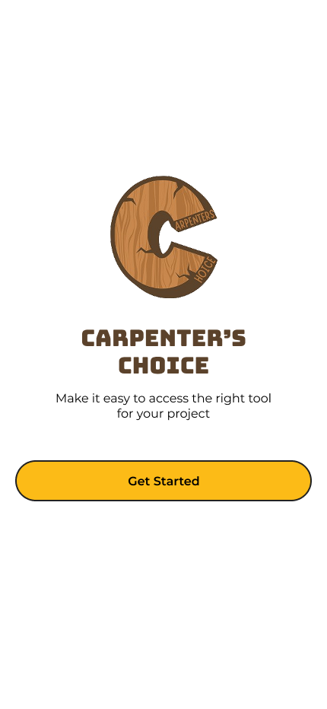
UI Design

 | Name | Description | Parameter | Action
1 | Carpenter’s Choice Logo | ImageView of the logo of Carpenter’s Choice | android:src="@drawable/carpenters_choice_logo"
2 | Carpenter’s Choice Slogan | TextView of the Carpenter’s Choice Slogan saying “Make it easy to access the right tool for your project” | android:text="@strings/carpenters_choice_slogan"
3 | Get Started Button | Yellow button with the text “Get Started” | android:background="@colors/primary"  android:text=@strings/get_started_cta" | Leads to Login Activity

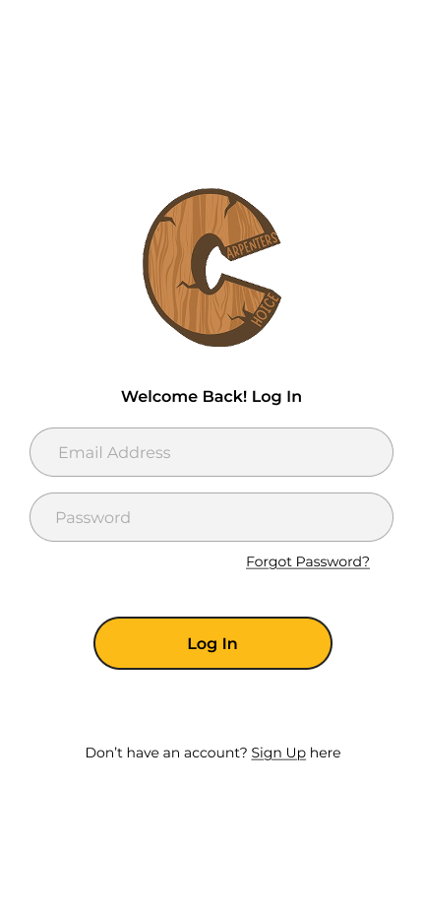

 | Name | Description | Parameter | Action
4 | Carpenter’s Choice Logo | ImageView of the logo of Carpenter’s Choice without the text | android:src="@drawable/carpenters_choice_logo_no_text"
5 | Welcome Back Message | TextView that says “Welcome Back! Log In” | android:text="@strings/decor_welcome_back"
6 | Email Address Field | EditText for inputting user’s email address | android:hint="@strings/placeholder_email"  android:inputType="textEmailAddress"
7 | Password Field | EditText for inputting user’s password | android:hint="@strings/placeholder_password"  android:inputType="textPassword"
8 | Forgot Password Link | Underlined link with text “Forgot Password” | android:text="@strings/link_forgot_password"  android:textColorLink="@colors/mono_lgray" | Leads to Forgot Password Activity
9 | Login Button | Button with the text “Log In” | android:text="@strings/btn_login"  android:background="@colors/primary"
10 | Sign Up Link | Link with text “Don’t have an account? Sign Up here” | android:text="@strings/link_signup"  android:textColorLink="@colors/mono_black" | Leads to Sign Up Activity
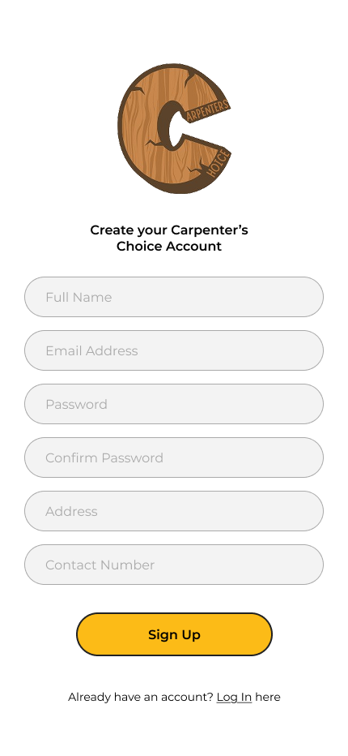

 | Name | Description | Parameter | Action
11 | Carpenter’s Choice Logo | ImageView of the logo of Carpenter’s Choice without the text | android:src="@drawable/carpenters_choice_logo_no_text"
12 | Welcome Message | TextView that says “Create your Carpenter’s Choice Account” | android:text="@strings/decor_welcome_back”
13 | Full Name Field | EditText for inputting user’s full name | android:hint="@strings/placeholder_fullname"  android:inputType="textPersonName"
14 | Email Address Field | EditText for inputting user’s email address | android:hint="@strings/placeholder_email"  android:inputType="textEmailAddress"
15 | Password Field | EditText for inputting user’s password | android:hint="@strings/placeholder_password"  android:inputType="textPassword"
16 | Confirm Password Field | EditText to confirm user’s password | android:hint="@strings/placeholder_confirm password"  android:inputType="textPassword"
17 | Address Field | EditText for inputting user’s complete address | android:hint="@strings/placeholder_address"  android:inputType="textPostalAddress"
18 | Contact Number Field | EditText for inputting user’s contact number | android:hint="@strings/placeholder_phone"  android:inputType="phone"
19 | Sign Up Button | Button with the text “Sign Up” | android:text="@strings/btn_signup"  android:background="@colors/primary” | Creates an account and redirects the user to dashboard
20 | Log In Link | Link with text “Already have an account? Log In here” | android:text="@strings/link_login"  android:textColorLink="@colors/mono_lgray" | Leads to Log In Activity
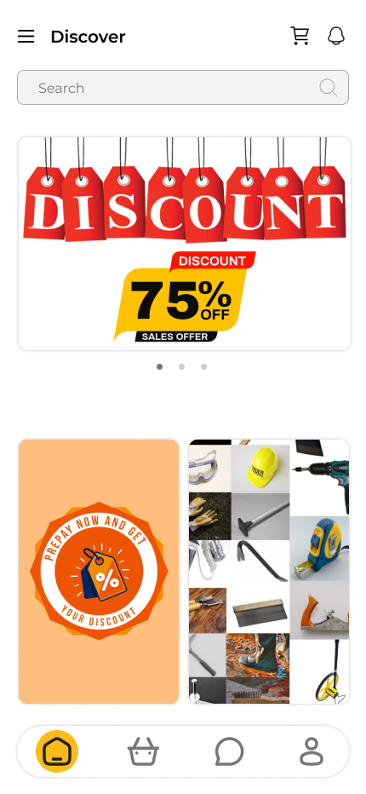

 | Name | Description | Parameter | Action
21 | Sidebar Navigation Button | ImageButton with the hamburger icon | android:src="@drawable/ic_hamburger"  android:contentDescription="@string/decor_nav_button" | Opens up the sidebar navigation
22 | Discover | TextView for the page title | android:text="@string/pagetitle_discover"
23 | Cart Button | ImageButton with the shopping cart icon | android:src="@drawable/ic_cart"  android:contentDescription="@string/link_cart" | Leads to Cart Activity
24 | Notifications Button | ImageButton with bell icon | android:src="@drawable/ic_bell"  android:contentDescription="@string/link_notifications" | Leads to Notification Activity
25 | Search Field | EditText for searching products. Contains placeholder text “Search” | android:hint="@string/placeholder_search"  android:inputType="textAutoComplete" | On input, displays all the products matching the keyword
26 | Primary Promotions Area | ImageView that slideshows product promotions and discounts | android:contentDescription="@string/decor_promo_primary"  android:scaleType="centerCrop"
27 | Secondary Promotions Area | ImageView that slideshows product promotions and discounts | android:contentDescription="@string/decor_promo_secondary"  android:scaleType="centerCrop"
28 | Home Button - Bottom Navigation | ImageButton with a home icon and yellow background that indicates active state | android:src="@drawable/ic_home"  android:background="@drawables/borders_round_full"  android:backgroundTint="@colors/primary"  android:contentDescription="@string/btmnav_home" | Leads to Dashboard Screen
29 | New Arrivals Button - Bottom Navigation | ImageButton with a basket icon | android:src="@drawable/ic_basket"  android:contentDescription="@string/btmnav_new_arrivals" | Leads to New Arrivals Screen
30 | Messages Button - Bottom Navigation | ImageButton with a message bubble icon | android:src="@drawable/ic_message"  android:contentDescription="@string/btmnav_messages" | Leads to Messages Screen
31 | Account Button - Bottom Navigation | ImageButton with a user icon | android:src="@drawable/ic_user"  android:contentDescription="@string/btmnav_account" | Leads to Account Screen

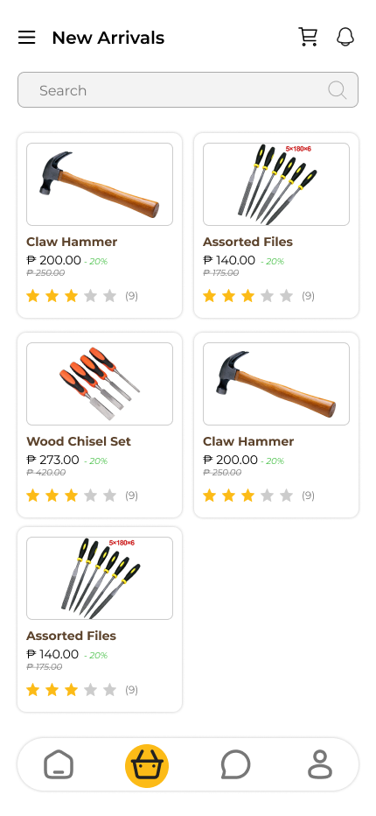

 | Name | Description | Parameter | Action
32 | Search Field | EditText for searching products. Contains placeholder text “Search” | android:hint="@string/placeholder_search"  android:imeOptions="actionSearch" | On input, displays all the products matching the keyword
33 | Products Recycler View | RecyclerView that displays all the featured products or products that matched the search | app:spanCount="2"  android:clipToPadding="false"
34 | Product Container | LinearLayout that holds the product information | android:background="?selectableItemBackground"  android:orientation="vertical" | Leads to Product Activity with chosen product’s information
35 | Product Image - Product Container | ImageView that shows product image | android:scaleType="centerCrop"  android:contentDescription="@string/decor_product_image"
36 | Product Name - Product Container | TextView that displays the product name | android:textSize="14sp"  android:maxLines="2"
37 | Product Price - Product Container | TextView that shows product price | android:textColor="@colors/primary"  android:textSize="16sp"
38 | Product Discount - Product Container | TextView in green color that shows product discount | android:textColor="@color/green"  android:background="@drawable/bg_discount_badge"
39 | Product Original Price - Product Container | TextView with strikethrough line that shows product’s original price before discount | android:paintFlags="strikeThruText"  android:textSize="12sp"
40 | Product Star Ratings - Product Container | ImageView of star icons that show the average star rating of product | android:src="@drawable/ic_stars_4" (dynamic)
41 | Product Feedback Counter- Product Container | TextView that shows how many users rated the product | android:textSize="12sp"  android:textColor="@color/gray"

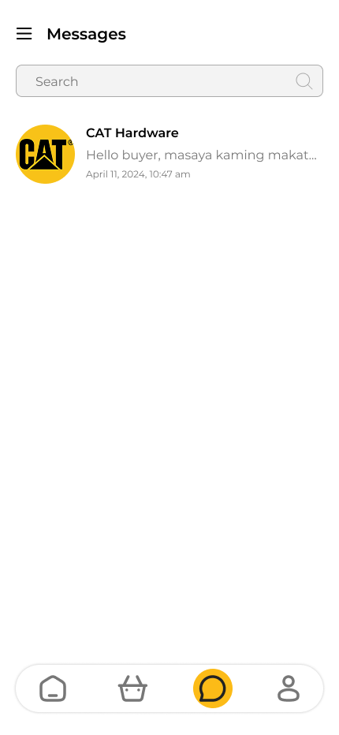

 | Name | Description | Parameter | Action
42 | Search Field | EditText for searching messages. Contains placeholder text “Search” | android:hint="@string/placeholder_search_messages"  android:inputType="textAutoComplete" | On input, displays all the conversations matching the keyword
43 | Messages RecyclerView | RecyclerView that displays all the conversations fetched | android:id="@+id/rvConversations"  app:layoutManager="LinearLayoutManager"
44 | Conversation Container | LinearLayout that holds the conversation information | android:background="?selectableItemBackground"  android:orientation="horizontal" | Leads to Conversation Activity with chosen conversation information
45 | Recipient Image - Conversation Container | ImageView that shows profile image of the recipient | android:contentDescription="@string/decor_recipient_image"  android:scaleType="centerCrop"
46 | Recipient Name - Conversation Container | TextView that displays the name of recipient | android:textSize="16sp"  android:textStyle="bold"  android:textColor="@color/black"
47 | Message Excerpt - Conversation Container | TextView that displays an excerpt of the last message sent/received | android:textSize="14sp"  android:maxLines="1"  android:ellipsize="end"
48 | Message Timestamp - Conversation Container | TextView that shows time of when the message is sent | android:textSize="12sp"  android:textColor="@color/gray"  android:layout_gravity="end"

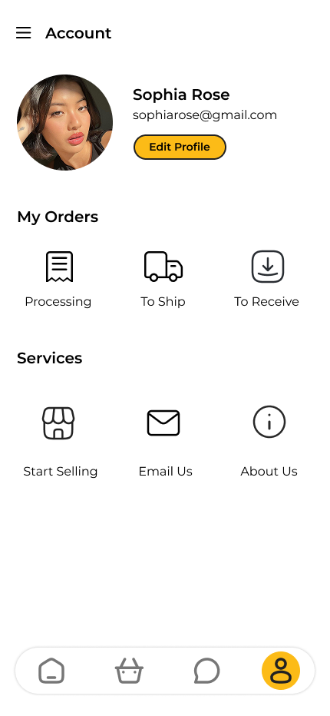

 | Name | Description | Parameter | Action
49 | Account Image | ImageView that contains the user’s profile image | android:src="@drawable/default_profile"  android:contentDescription="@string/decor_profile_image"  android:clickable="true" | Opens a menu that lets users to take photo or choose image to replace their current profile image
50 | Full Name | TextView that displays user’s full name | android:textSize="18sp"  android:textStyle="bold"  android:textColor="@color/black"
51 | Email Address | TextView that displays user’s email address | android:textSize="14sp"  android:textColor="@color/gray"
52 | Edit Profile Button | Yellow button with text “Edit Profile” | android:text="@string/btn_edit_profile"  android:background="@colors/primary" | Leads to Edit Profile Activity
53 | My Orders | TextView for the view group | android:text="@string/decor_my_orders"  android:textStyle="bold"
54 | Processing Image Button | ImageButton with receipt icon and text saying “Processing” | android:src="@drawable/ic_receipt"  android:text="@string/link_processing_orders" | Leads to Transaction History with Processing Filter
55 | To Ship Image Button | ImageButton with delivery truck icon and text saying “To Ship” | android:src="@drawable/ic_delivery_truck"  android:text="@string/link_to_ship_orders" | Leads to Transaction History with To Ship Filter
56 | To Receive Image Button | ImageButton with boxed arrow down icon and text saying “To Receive” | android:src="@drawable/ic_box_arrow_down"  android:text="@string/link_to_receive_orders" | Leads to Transaction History with To Receive Filter
57 | Services | TextView for the view group | android:text="@string/decor_services"  android:textStyle="bold"
58 | Start Selling Image Button | ImageButton with boxed arrow down icon and text saying “To Receive” | android:src="@drawable/ic_store"  android:text="@string/link_start_selling" | Leads to online website for vendors page
59 | Email Us Image Button | ImageButton with boxed arrow down icon and text saying “Email Us” | android:src="@drawable/ic_email"  android:text="@string/link_email_us" | Leads to device’s primary email service’s email compose
60 | About Us Image Button | ImageButton with boxed arrow down icon and text saying “About Us” | android:src="@drawable/ic_info"  android:text="@string/link_about_us" | Leads to online website’s about us page

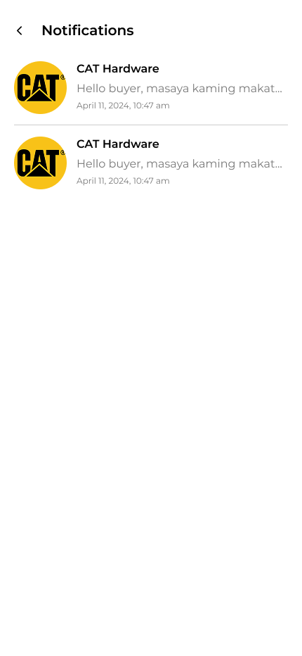

 | Name | Description | Parameter | Action
61 | Notifications RecyclerView | RecyclerView that displays all the notifications fetched | android:id="@+id/rvNotifications"  app:layoutManager="LinearLayoutManager"
62 | Notification Container | LinearLayout that holds the information of the notification | android:background="?selectableItemBackground"  android:orientation="horizontal" | Leads user to the appropriate screen depending on notif type
63 | Sender Image | ImageView that contains the profile image of the user/shop/system triggering the notification | android:contentDescription="@string/decor_sender_image"  android:scaleType="centerCrop"
64 | Sender Name | TextView that displays the name of the user/shop/system | android:textSize="14sp"  android:textStyle="bold"
65 | Notification Details | TextView that displays the notification’s content | android:textSize="14sp"  android:maxLines="2"  android:ellipsize="end"
66 | Notification Timestamp | TextView that shows time of when the notification is sent | android:textSize="12sp"  android:textColor="@color/gray"
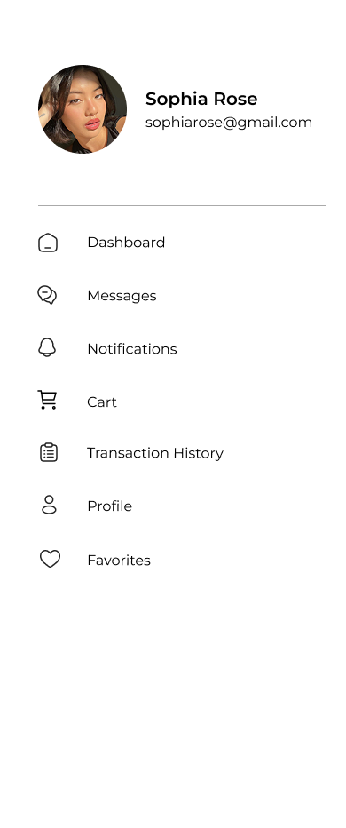

 | Name | Description | Parameter | Action
67 | Account Image | ImageView that contains the user’s profile image | android:src="@drawable/default_profile"  android:contentDescription="@string/decor_profile_image"  android:layout_width="80dp"  android:layout_height="80dp"
68 | Full Name | TextView that displays user’s full name | android:textSize="16sp"  android:textStyle="bold"  android:textColor="@color/black"
69 | Email Address | TextView that displays user’s email address | android:textSize="14sp"  android:textColor="@color/gray"
70 | Dashboard | ListView Item containing an ImageView of home icon and TextView with text “Dashboard” | android:icon="@drawable/ic_home"  android:title="@string/link_dashboard" | Leads to Dashboard Screen
71 | Messages | ListView Item containing an ImageView of home icon and TextView with text “Messages” | android:icon="@drawable/ic_message"  android:title="@string/link_messages" | Leads to Messages Screen
72 | Notifications | ListView Item containing an ImageView of bell icon and TextView with text “Notifications” | android:icon="@drawable/ic_bell"  android:title="@string/link_notifications" | Leads to Notification Activity
73 | Cart | ListView Item containing an ImageView of cart icon and TextView with text “Cart” | android:icon="@drawable/ic_cart"  android:title="@string/link_cart" | Leads to Cart Activity
74 | Transaction History | ListView Item containing an ImageView of home icon and TextView with text “Transaction History” | android:icon="@drawable/ic_receipt"  android:title="@string/link_transaction_history" | Leads to Transaction History Activity
75 | Profile | ListView Item containing an ImageView of home icon and TextView with text “Profile” | android:icon="@drawable/ic_user"  android:title="@string/link_profile" | Leads to Account Screen
76 | Favorites | ListView Item containing an ImageView of home icon and TextView with text “Favorites” | android:icon="@drawable/ic_user"  android:title="@string/link_favpritess" | Leads to Favorites Activity

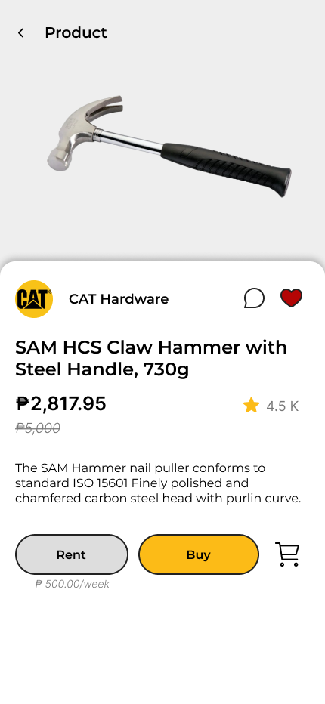

 | Name | Description | Parameter | Action
77 | Product Image | ImageView that contains the product image | android:scaleType="centerCrop"  android:contentDescription="@string/decor_product_image"
78 | Shop Image | ImageView that contains the shop’s profile image | android:src="@drawable/default_shop"  android:contentDescription="@string/decor_shop_image"
79 | Shop Name | TextView that displays shop’s name | android:textSize="14sp"  android:textStyle="bold"
80 | Messages Button | ImageButton with message bubble icon | android:src="@drawable/ic_message"  android:contentDescription="@string/link_contact_seller" | Leads to Conversation Activity of user’s and shop’s
81 | Add to Favorites Button | ImageButton with heart icon | android:src="@drawable/ic_heart_outline"  android:contentDescription="@string/btn_toggle_favorite" | Adds product to Favorites and turns icon to red
82 | Product Name | TextView that displays the product name | android:textSize="18sp"  android:textStyle="bold"
83 | Product Price | TextView that shows product price | android:textSize="16sp"  android:textColor="@colors/primary"
84 | Product Original Price | TextView with strikethrough line that shows product’s original price before the current price | android:textSize="14sp"  android:paintFlags="strikeThruText"
85 | Product Description | TextView which contains the description of the product | android:textSize="14sp"  android:lineSpacingExtra="4dp"
86 | Rent Button | Gray button with text “Rent” | android:text="@string/btn_rent"  android:background="@color/mono_lgray" | Shows rent form
87 | Rent Per Period | TextView that displays the rent rate of the product per period of time | android:textSize="12sp"  android:textColor="@color/gray"
88 | Buy Button | Yellow button with text “Buy” | android:text="@string/btn_buy"  android:background="@colors/primary" | Shows buy form
89 | Add to Cart Button | ImageButton with cart icon | android:src="@drawable/ic_cart_add"  android:contentDescription="@string/btn_add_to_cart" | Adds product to cart

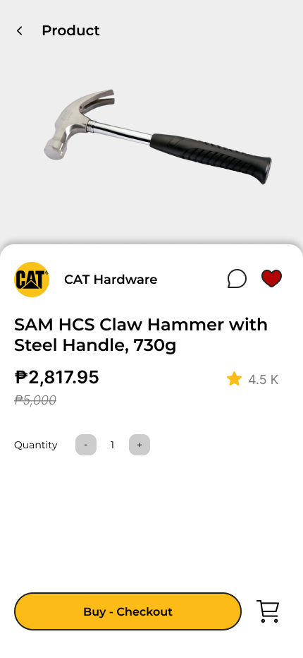

 | Name | Description | Parameter | Action
90 | Quantity | TextView with text “Quantity” | android:text="@string/label_quantity"  android:textSize="14sp"
91 | Minus Button | ImageButton with minus sign | android:src="@drawable/ic_minus"  android:contentDescription="@string/btn_decrease_qty" | Decreases quantity of product to be ordered
92 | Quantity Number | TextView that displays the current quantity of product to be ordered | android:text="1"  android:textSize="16sp"  android:minWidth="24dp"
93 | Add Button | ImageButton with plus sign | android:src="@drawable/ic_plus"  android:contentDescription="@string/btn_increase_qty" | Increases quantity of product to be ordered
94 | Buy - Checkout Button | Yellow button with text “Buy - Checkout” | android:text="@string/btn_buy_checkout"  android:background="@colors/primary" | Proceeds to checkout the product
95 | Add to Cart Button | ImageButton with cart icon | android:src="@drawable/ic_cart_add"  android:contentDescription="@string/btn_add_to_cart" | Adds the product to cart with the quantity and buy state

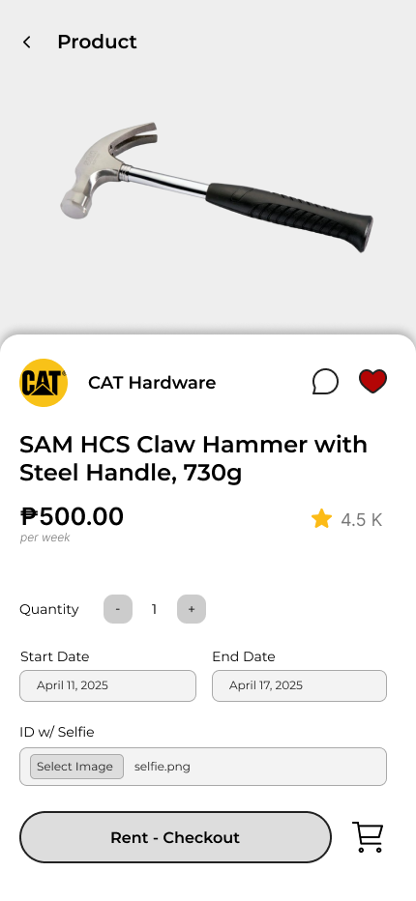

 | Name | Description | Parameter | Action
96 | Quantity | TextView with text “Quantity” | android:text="@string/label_quantity"  android:textSize="14sp"
97 | Minus Button | ImageButton with minus sign | android:src="@drawable/ic_minus"  android:contentDescription="@string/btn_decrease_qty"  android:enabled="false" (when qty=1) | Decreases quantity of product to be ordered
98 | Quantity Number | TextView that displays the current quantity of product to be ordered | android:text="1"  android:textSize="16sp"  android:minWidth="24dp"
99 | Add Button | ImageButton with plus sign | android:src="@drawable/ic_plus"  android:contentDescription="@string/btn_increase_qty" | Increases quantity of product to be ordered
100 | Start Date Field | DatePicker for the start date of rent | android:hint="@string/placeholder_start_date"  android:inputType="date" | Opens a datepicker
101 | End Date Field | DatePicker for the end date of rent | android:hint="@string/placeholder_end_date"  android:inputType="date" | Opens a datepicker
102 | ID w/ Selfie Field | Button and TextView for ID w/ Selfie | Button: android:text="@string/btn_upload_id"  TextView: android:text="" | On upload, the text view changes to the filename of the file uploaded
103 | Buy - Checkout Button | Yellow button with text “Buy - Checkout” | android:text="@string/btn_buy_checkout"  android:background="@colors/primary" | Proceeds to checkout the product
104 | Add to Cart Button | ImageButton with cart icon | android:src="@drawable/ic_cart_add"  android:contentDescription="@string/btn_add_to_cart" | Adds the product to cart with the quantity and buy state

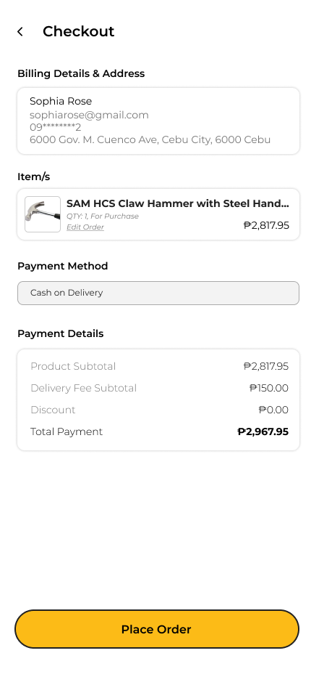

 | Name | Description | Parameter | Action
105 | Billing Details and Address | TextView labeling the view group | android:text="@string/decor_billing_details"  android:textStyle="bold"
106 | Full Name | TextView for customer’s name | android:textSize="14sp"
107 | Email Address | TextView for customer’s email address | android:textSize="14sp"
108 | Contact Number | TextView for customer’s contact number | android:textSize="14sp"
109 | Address | TextView for customer’s address | android:textSize="14sp"  android:maxLines="2"
110 | Item/s | TextView labeling the view group | android:text="@string/decor_order_items"  android:textStyle="bold"
111 | Products ListView | ListView containing all the products for checkout | android:divider="@color/divider_gray"  android:dividerHeight="1dp"
112 | Product Name | TextView that displays the product name | android:textSize="14sp"  android:textStyle="bold"
113 | Product Order Details | TextView displaying concise details of the product ordered | android:textSize="12sp"
114 | Edit Order Button | Button with text “Edit Order” | android:text="@string/btn_edit_order"  android:textColor="@colors/primary" | Lead’s to product buy/rent form
115 | Single Product Order Total | TextView that displays the total price of product multiplied by quantity ordered | android:textSize="14sp"  android:textStyle="bold"
116 | Payment Method | TextView labeling the view group | android:text="@string/decor_payment_method"  android:textStyle="bold"
117 | Payment Method Spinner | Spinner for choosing Payment method | android:entries="@array/payment_methods"  android:prompt="@string/prompt_payment_method" | Opens payment method options
118 | Payment Method | TextView labeling the view group | android:text="@string/decor_payment_summary"
119 | Product Subtotal | TextView for the total of ordered products’ cost | android:textSize="14sp"
120 | Delivery Fee Subtotal | TextView for delivery cost | android:textSize="14sp"
121 | Discount | TextView for discount applied | android:textColor="@color/green"
122 | Total Payment | Bold TextView that displays the final amount to be paid | android:textSize="16sp"  android:textStyle="bold"
123 | Place Order Button | Yellow button with text “Place Order” | android:text="@string/btn_place_order"  android:background="@colors/primary" | Sends order to the system

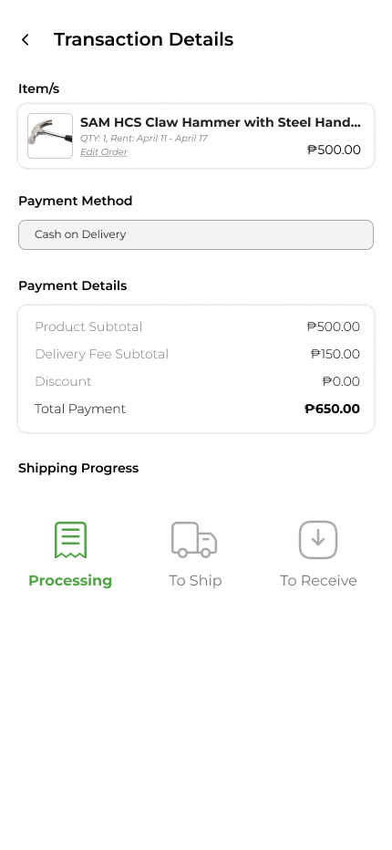

# | Name | Description | Parameter | Action
124 | Products ListView | ListView containing all the products for checkout | android:id="@+id/lvOrderItems"  android:divider="@color/divider_gray"
125 | Product Name | TextView that displays the product name | android:textSize="16sp"  android:textStyle="bold"
126 | Product Order Details | TextView displaying concise details of the product ordered | android:textSize="14sp"  android:textColor="@color/gray"
127 | Edit Order Button | Button with text “Edit Order” | android:text="@string/btn_edit_order"  android:textColor="@colors/primary" | Lead’s to product buy/rent form
128 | Single Product Order Total | TextView that displays the total price of product multiplied by quantity ordered | android:textSize="16sp"  android:textStyle="bold"
129 | Payment Method | TextView labeling the view group | android:text="@string/decor_payment_method"  android:textStyle="bold"
130 | Product Subtotal | TextView for the total of ordered products’ cost | android:textSize="14sp"
131 | Delivery Fee Subtotal | TextView for delivery cost | android:textSize="14sp"
132 | Discount | TextView for discount applied | android:textColor="@color/green"
133 | Total Payment | Bold TextView that displays the final amount to be paid | android:textSize="18sp"  android:textStyle="bold"
134 | Shipping Progress | TextView for order status. Indicates the current stage of order fulfillment (e.g., Processing). | android:text="@string/status_processing"  android:textColor="@colors/primary"
135 | To Ship Indicator | TextView or Progress Step. Shows that the order is pending shipment | android:text="@string/status_to_ship"  android:textColor="@color/gray" | .
136 | To Receive Indicator | TextView or Progress Step.  Shows that the order is pending delivery. | android:text="@string/status_to_receive"  android:textColor="@color/gray"

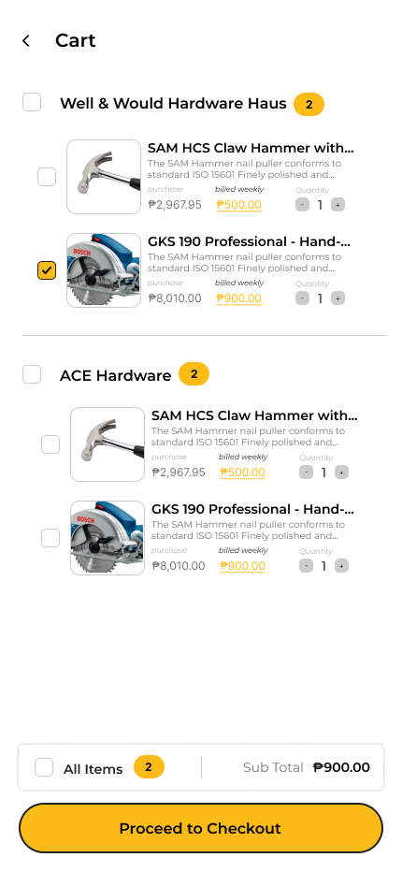

# | Name | Description | Parameter | Action
137 | Store Checkbox | Checkbox for store selection | android:id="@+id/cbStore"  android:buttonTint="@colors/primary" | Toggles selection of all items under the store.
138 | Product Name | TextView that displays the product name | android:textSize="16sp"  android:textStyle="bold"
139 | Product Description | TextView displaying excerpt of the details of the product | android:textSize="12sp"  android:maxLines="2"
140 | Purchase Text Button | Button & TextView indicating purchase/buy type and buy price | android:text="@string/btn_purchase"  style="@style/OrderTypeButton" | Changes order type to buy on tap, turns buy price to yellow
141 | Rent Text Button | Button & TextView indicating rent type and rent price per rent period | android:text="@string/btn_rent"  style="@style/OrderTypeButton" | Changes order type to rent on tap, turns rent price to yellow
142 | Quantity Selector | Buttons & TextView that controls/displays order quantity for the product | [ - 1 + ] layout  android:minWidth="24dp" | Increases/decreases item quantity.
143 | All Items Toggle | Button to select/deselect all items | android:text="@string/btn_select_all" | Toggles selection of all cart items.
144 | Item Count | Displays total selected items | android:textSize="14sp"  format="@string/format_item_count"
145 | Subtotal Label | Displays aggregated cost | android:textSize="16sp"  android:textStyle="bold"
146 | Checkout Button | Yellow button that says “Proceed to Checkout” | android:text="@string/btn_proceed_checkout"  android:background="@colors/primary" | Leads to Checkout Activity with products selected
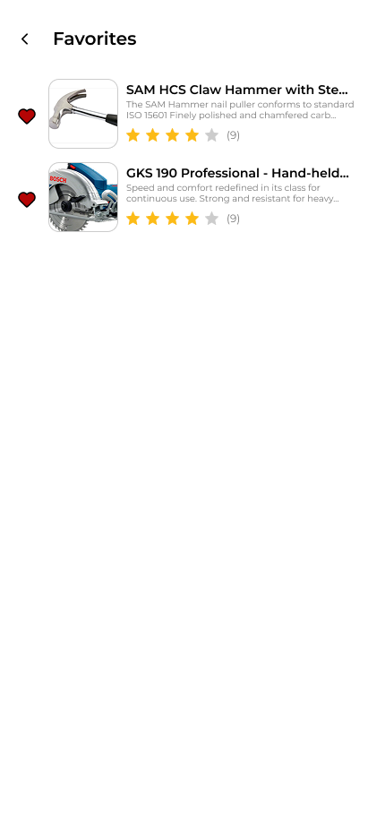

# | Name | Description | Parameter | Action
147 | Favorite Products’ RecyclerView | RecyclerView for displaying all favorited products fetched | android:id="@+id/rvFavProds"  app:layoutManager="LinearLayoutManager"
148 | Product ListItem | LinearLayout for containing all product information | android:background="?selectableItemBackground"  android:orientation="horizontal"
149 | Heart Button | ImageButton with the heart icon | android:src="@drawable/ic_heart_outline"  android:contentDescription="@string/btn_toggle_favorite" | Asks for confirmation, then removes product from favorites
150 | Product Image | ImageView that contains the product image | android:scaleType="centerCrop"  android:contentDescription="@string/decor_product_image"
151 | Product Description | TextView displaying excerpt of the details of the product | android:textSize="12sp"  android:maxLines="2"
152 | Product Star Ratings - Product Container | ImageView of star icons that show the average star rating of product | android:src="@drawable/ic_stars_4" (dynamic)
153 | Product Feedback Counter- Product Container | TextView that shows how many users rated the product | android:textSize="12sp"  android:textColor="@color/gray"

Test Plan
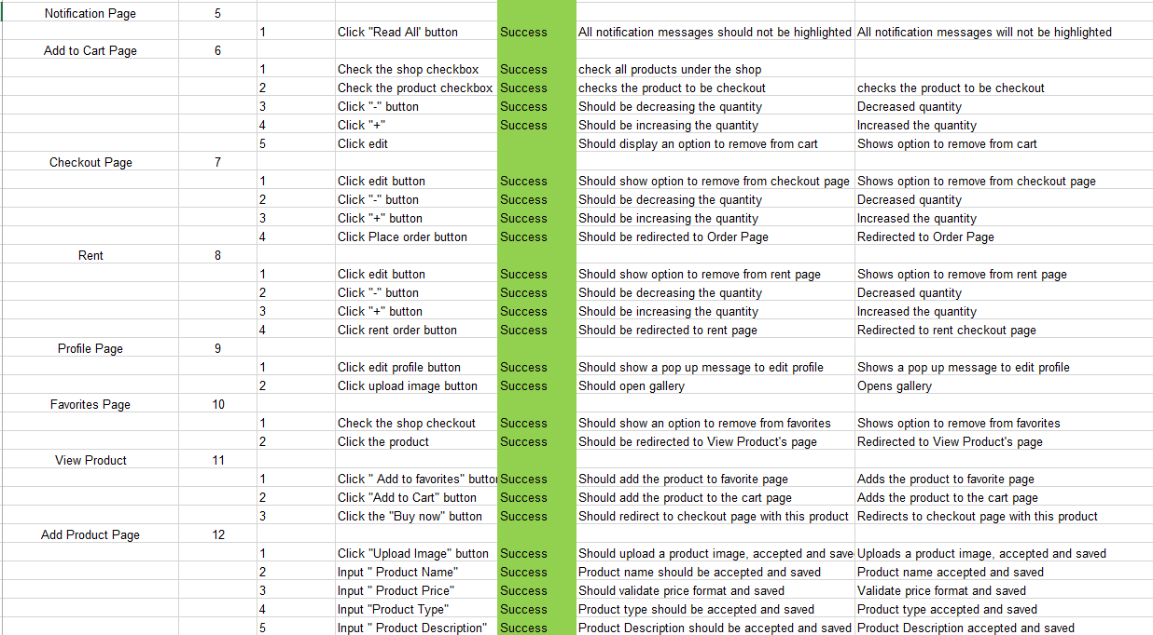
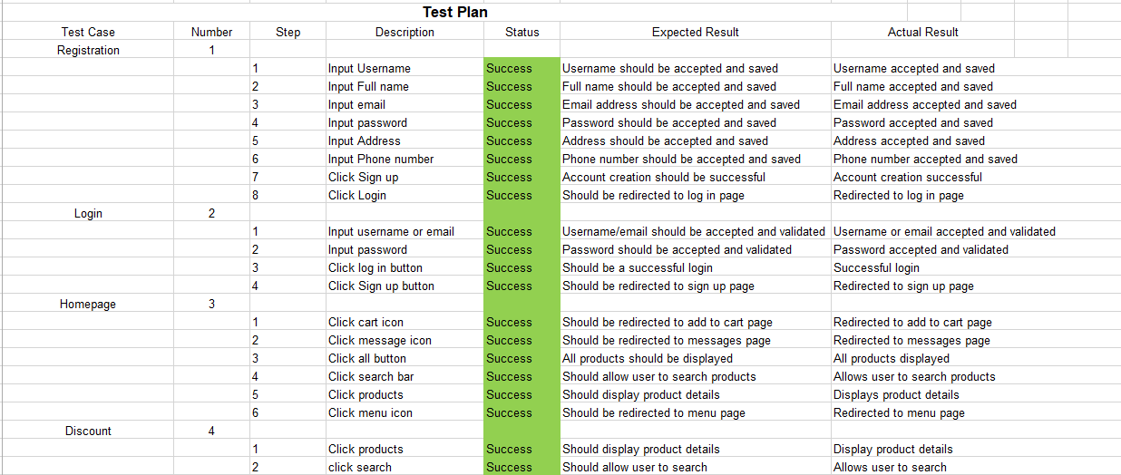

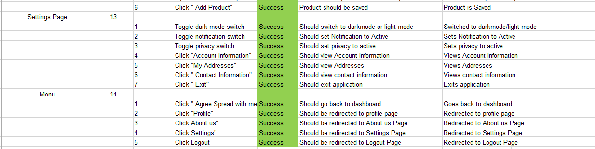

Sequence Diagram
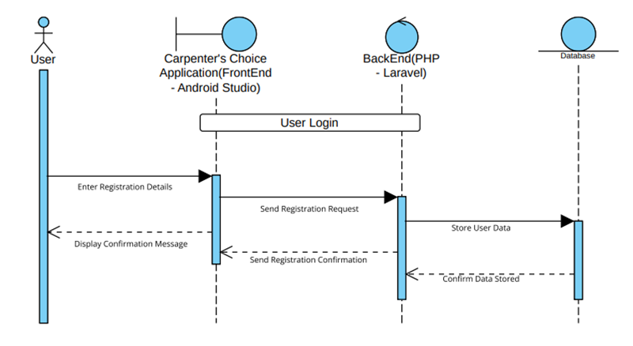
Registration Page
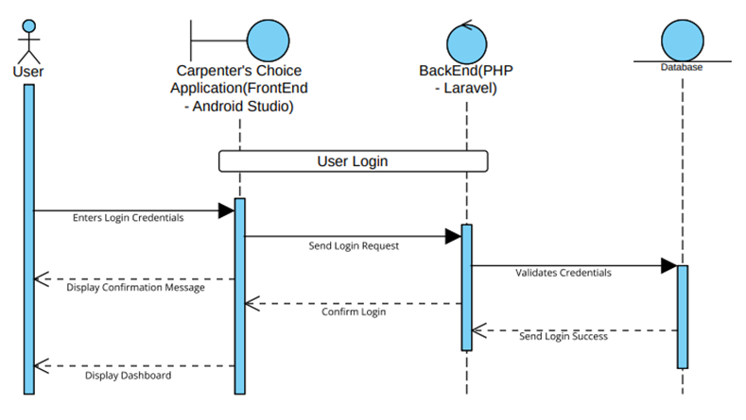
User Login
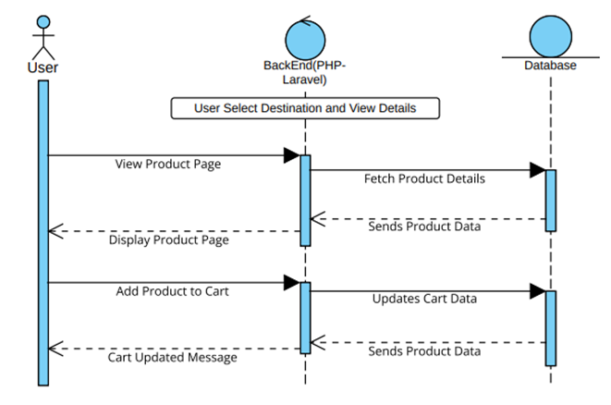
User Select Destination and View Details
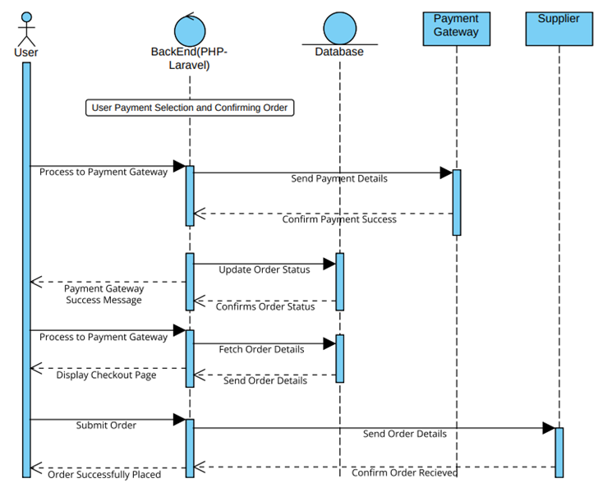
User Payment Selection and Confirming Order

